Question-1:
a) What is an SNN? How is an SNN different from an ANN? Why is it hard to implement SNNs on IoT or embedded systems? -2.5 Marks
b) What is LLMu module? Describe the internal structure and operation of the LLMu module, including fractional processing and error compensation for improved accuracy. -2.5 Marks

Answers:
Answer to the question no.-1 (a):
What is an SNN?
A Spiking Neural Network (SNN) is a type of neural network inspired by how the human brain works. Instead of continuously passing numerical values, its neurons communicate using short electrical signals called spikes. SNNs are useful for applications such as image processing, robotics, motor control, and event-based data processing.
How is an SNN different from an ANN?
The main difference is how neurons communicate:
- ANN (Artificial Neural Network): Neurons continuously process and pass numerical values between layers.
- SNN (Spiking Neural Network): Neurons communicate only when their membrane potential reaches a certain threshold, producing a spike.
So, ANNs work mainly with continuous numerical values, while SNNs work with discrete spikes over time.
Why is it hard to implement SNNs on IoT or embedded systems?
Although SNNs can be energy-efficient, implementing them on small IoT or embedded devices is challenging because:
- High hardware requirements: Large SNNs may contain many neurons and connections, requiring considerable memory and hardware resources.
- Irregular computation: Spikes occur asynchronously, making memory access and computation irregular. This is difficult for traditional hardware to handle efficiently.
- Computational cost: SNN training and some neuron/synapse operations can require many calculations, which increases processing time, energy consumption, and hardware requirements.

Answer to the question no.-1 (b):
The LLMu (Logarithmic Linear Multiply) module is a specialized hardware architecture designed to optimize multiplication operations within Spiking Neural Network (SNN).

The internal structure of the LLMu module is illustrated in the following figure-
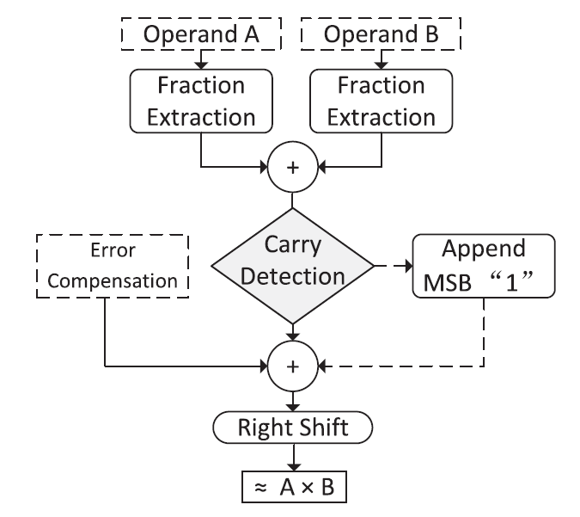
Operation of the LLMu module: Upon entering the LLMu module, the fractional parts of the operands are first extracted and summed. A carry detection operation determines whether the sum of the fractional parts exceeds one. This result subsequently influences both the selection of the error compensation constant and the final shift adjustment required for output correction.
The convex nature of the logarithmic function ensures that the linearly approximated multiplication result is consistently lower than the exact value, resulting in a negative error (P̃ -P). The average error can thus be computed and applied as a constant compensation, which improves overall accuracy without incurring additional hardware resource overhead.

